**Manav Rachna International Institute of Research and Studies**

**Bachelors in Computer Applications Data Structures using C**

**Submitted by:** Armaan Haider

**Department:** School of Computer Applications

**Course:** Bachelors in Computer Applications

**Roll No:** 24/SCA/BCA/059

**Semester:** 2nd

**Subject:** Data Structures using C

***Experiment no: 1***

**Aim**: To insert elements in an array.

**Program:**

#include<stdio.h> int main(){ int arr[10], n;

printf("Enter the number of elements you want.\n"); scanf("%d", &n);

printf("Enter the elements.\n"); for(int i=0; i<n; i++){ scanf("%d", &arr[i]);

}

printf("Elements inside array are:\n"); for(int i=0; i<n; i++){ printf("%d\t", arr[i]);

}

return 0;

}

**Output:**

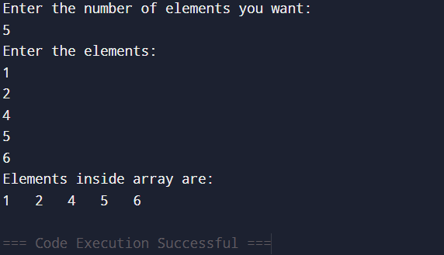

***Experiment* *no: 2***

**Aim:** To search for element inside of an array.

**Program:**

#include<stdio.h> int main(){ int arr[7] = {1,5,3,7,6,4,9}; int n, count=0;

printf("Enter the element that you want to search.\n"); scanf("%d", &n);

for(int i=0; i<7; i++){ if(arr[i] == n){ printf("%d is present at %d position\n", n, i+1); count += 1;

}

}

if(count == 0){ printf("%d not found.\n");

}

return 0;

}

**Output:**

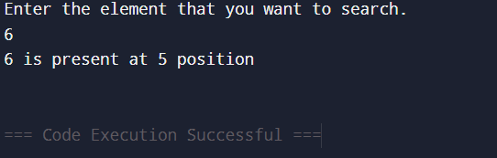

***Experiment no: 3***

**Aim:** To update element in an array.

**Program:**

#include<stdio.h> int main(){ int arr[7] = {1,2,3,4,5,6,7}; int pos, n;

printf("Elements of array before updation.\n"); for(int i=0; i<7; i++){ printf("%d\t", arr[i]);

}

printf("\nEnter the position of element you want to update.\n"); scanf("%d", &pos);

printf("Enter the value you want to update.\n"); scanf("%d", &n);

arr[pos-1] = n; // Updating the element.

printf("Elements of array after updation.\n"); for(int i=0; i<7; i++){ printf("%d\t", arr[i]);

}

return 0;

}

**Output:**

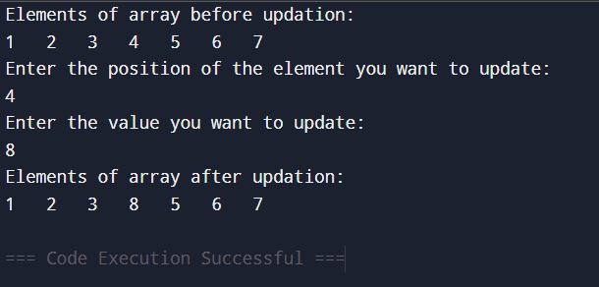

***Experiment no: 4***

**Aim:** To delete element from an array.

**Program:**

#include<stdio.h> int main(){ int arr[7] = {1,2,3,4,5,6,7}; int n, count=0;

printf("Elements of array before deletion:\n"); for(int i=0; i<7; i++){ printf("%d\t", arr[i]);

}

printf("\nEnter the element that you want to delete.\n"); scanf("%d", &n);

for(int i=0; i<7; i++){ if(arr[i] == n){ count += 1;

for(int j=i; j<6; j++){ arr[j] = arr[j+1];

}

}

}

if(count == 0){ printf("%d not found\n", n);

}

else{ printf("Elements of array after deletion:\n"); for(int i=0; i<6; i++){ printf("%d\t", arr[i]);

}

}

return 0;

}

**Output:**

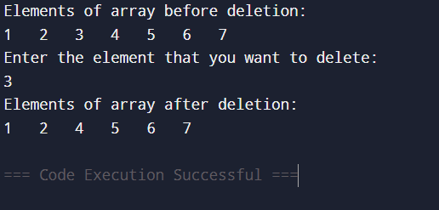

***Experiment no: 5***

**Aim:** To sort elements in an array.

**Program:**

#include<stdio.h> int main(){ int arr[7] = {4,2,6,8,5,1,9}; int temp;

printf("Initial Array:\n"); for(int i=0; i<7; i++){ printf("%d\t", arr[i]);

}

printf("\nSorting in ascending order:\n");

for(int i=0; i<7; i++){ for(int j=0; j<6; j++){ if(arr[j] > arr[j+1]){ temp = arr[j]; arr[j] = arr[j+1]; arr[j+1] = temp;

}

}

}

for(int i=0; i<7; i++){ printf("%d\t", arr[i]);

}

printf("\nSorting in descending order:\n");

for(int i=0; i<7; i++){ for(int j=0; j<6; j++){ if(arr[j] < arr[j+1]){ temp = arr[j]; arr[j] = arr[j+1]; arr[j+1] = temp;

}

}

}

for(int i=0; i<7; i++){ printf("%d\t", arr[i]);

}

return 0;

}

**Output:**

